**Misr University for Science and Technology**

**College of Engineering**

**Mechatronics Lab**

FINITE STATE MACHINE MODULE

PNEUMATIC SQUENCING SYSTEM

# Objective

The experiment is aimed to implement a mechatronic philosophy by means of sequential logic. This methodology is reached via state machine.

# Outcome

* Full comprehension of sequential logic methodology.
* The code of practice for embedded systems design using Finite State Machine (FSM).
* Building fully functional pneumatic sequential circuit controlled by microcontroller.
* Abstraction of design using rapid prototyping software like LabVIEW.

# System Block Diagram:

Two double cylinders are utilized to perform sequencing. Each cylinder is operated by 5/3 double solenoid valve. Relay shield is used for isolation of control circuit from power circuit.

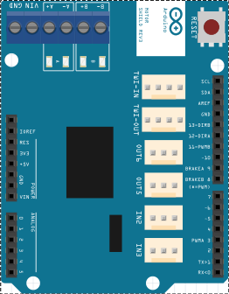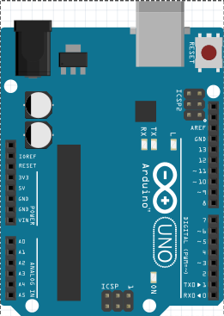



Pneumatic Circuit

Figure Block Diagram

# Knowledge required

Student is expected to be familiar with the theory of Ziegler- Nicholas and its theoretical calculations.

# PI Tuning of process without delay

**IMPORTANT**: before you begin, make sure the three way valve handle (*found behind the tank with “H” label*) is put into this position:

Figure Three way valve position (no delay)

## Searching for the critical gain

1. Turn the air compressor and water pump **off.**
2. Set the Proportional Factor (PF) to 3% (aka *Proportional Band (PB)*), Integral Factor (IF) to 200 minutes/repeat and Derivative Factor (DF) to 0.0 minutes.
3. Adjust the **set point** to 50% of the full scale.
4. Open the manual discharging valve **half turn** from the fully closed position**.**
5. Record the reading of action bar graph maxima and minima every minute for 10 minutes.
6. Repeat steps from (A-E) for PF values of (3-6%).
7. Record the values in the below tables and write down your comment on the oscillation behavior (conversion, diversion, steady … etc) :

|  |  |  |  |  |
| --- | --- | --- | --- | --- |
| **PF (%)** | **IF (min/rep.)** | **DF (min)** | **Actionmin (%)** | **Actionmax (%)** |
| **3** | **200** | **0** |  |  |
|  |  |
|  |  |
|  |  |
|  |  |
|  |  |
|  |  |
|  |  |
|  |  |
|  |  |
| ***Comment*** | | *signal is diverted towards instability* | | |

|  |  |  |  |  |
| --- | --- | --- | --- | --- |
| **PF (%)** | **IF (min/rep.)** | **DF (min)** | **Actionmin (%)** | **Actionmax (%)** |
| **4** | **200** | **0** |  |  |
|  |  |
|  |  |
|  |  |
|  |  |
|  |  |
|  |  |
|  |  |
|  |  |
|  |  |
| ***Comment*** | | *System is marginally stable* | | |

|  |  |  |  |  |
| --- | --- | --- | --- | --- |
| **PF (%)** | **IF (min/rep.)** | **DF (min)** | **Actionmin (%)** | **Actionmax (%)** |
| **5** | **200** | **0** |  |  |
|  |  |
|  |  |
|  |  |
|  |  |
|  |  |
|  |  |
|  |  |
|  |  |
|  |  |
| ***Comment*** | | *System is marginally stable* | | |

1. For values making the system marginally stable, calculate the periodic time 10 times every minute and take the average:

$$Ultimate time \left(T_{u}\right)= \sec{= min}$$

|  |  |  |  |  |
| --- | --- | --- | --- | --- |
| **PF (%)** | **IF (min/rep.)** | **DF (min)** | **Actionmin (%)** | **Actionmax (%)** |
| **6** | **200** | **0** |  |  |
|  |  |
|  |  |
|  |  |
|  |  |
|  |  |
|  |  |
|  |  |
|  |  |
|  |  |
| ***Comment*** | | *System oscillation is damped (convergence )* | | |

## Ziegler Nicholas parameters

From the conducted experiment, we can conclude the main parameters, namely:



$Critical Gain \left(K_{c} \right)=2.2*PB=2.2* =$

$Reset Time \left(T_{i} \right)=0.83{*T}_{u}=0.83* = min$

Since the Ziegler-Nicholas formula for **PI controller** action is:

$$W_{c}=K_{c}(1+\frac{1}{T_{i}S})$$

Which concludes the values of PI controller:

|  |  |
| --- | --- |
| PF (%) | IF (min/rep) |
|  | $$\frac{K_{c}}{T_{i}}=\frac{}{}=$$ |

## Validating the PI values

1. Change the values of PF to 10, IF to 66.66. Repeat the same procedures mentioned in section ‎5.1.